Continual Learning

Continual learning involves building models which can digest novel information over time without erasing what they already know (Copilot, 2026). It has become increasingly important in modern deep learning as systems are expected to adapt continuously in dynamic, real-world environments instead of depending on a single static training phase. The author stated, “Continual learning is an artificial intelligence (AI) learning approach that involves sequentially training a model for new tasks while preserving previously learned tasks” (What, 2026). The author stated, “Continual learning is the skill of incrementally learning from a non-stationary stream of data” (Van de Ven, 2024, p. 2). Furthermore, the author stated, “In this definition, the term “non-stationary” indicates that the distribution of the data from which is learned changes over time” (Van de Ven, 2024, p. 2). Continual learning remains an important research focus because modern AI systems must function in changing, non-stationary environments where the ability to retain and update knowledge is required for long-term performance.
Task-incremental learning is a continual-learning scenario in which a model is trained on a sequence of distinct tasks. It must know which task it is performing. A real-world analogy is learning multiple languages one after another. We know the specific language to use in any given case. The main goal is effective transfer learning across tasks.
Domain-incremental continual learning deals with situations in which the data distribution changes but the task itself remains the same. The model does not have to identify which specific task it is performing. It only needs to adjust to fresh environmental conditions while generating the same type of output. For example, an OCR system must continue recognizing text while document styles, fonts, or formats change. Because most models are trained on fixed, static datasets, distribution changes post deployment commonly degrade performance. Domain-incremental learning supplies mechanisms to lessen this loss. These mechanisms help models to adjust to changing input conditions. The author stated, “Illustrative examples of domain-incremental learning are learning to drive in various weather conditions or learning to classify objects under different lighting conditions (e.g., indoors versus outdoors)” (Van de Ven, 2024, p. 6).
Class-incremental continual learning is a setting where a model is trained on tasks which present new classes over time. The model must learn these novel classes without forgetting the previously learned ones.

Catastrophic forgetting destroys continual learning (Belcic & Stryker, 2026). The author stated, “Catastrophic forgetting is the phenomenon that artificial neural networks tend to rapidly and drastically forget previously learned information when learning new information” (Van de Ven, 2024, p. 2), (see Figure 1, Van de Ven, 2024, p. 3). When a neural network learns a new task, the gradients from that task overwrite the weights that were important for previous tasks. This causes the model to lose the representations it originally depended on. As a result, performance on previous tasks collapses. The network only functions like a single-task learner. Genuine sequential learning becomes impossible. The author stated, “The current inept ability of deep learning models to continually learn from a stream of incoming data is a major obstacle to the development of truly intelligent artificial agents that can accumulate knowledge by incrementally learning from their experiences” (Van de Ven, p. 13, 2024).
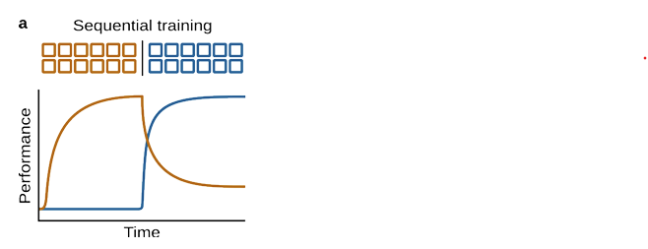Figure 1
The following four categories constitute the core defenses against catastrophic forgetting. First, regularization is used to minimize catastrophic forgetting. Elastic weight consolidation (EWC) is a regularization technique. It adds a penalty to the loss function for adjustments to model weights which are important for previous tasks. Synaptic intelligence disincentivizes the model from changing major parameters. Both elastic weight consolidation and synaptic intelligence remain important today. They are important in research and small-scale continual-learning experiments.
Second, architectural solutions are used to minimize catastrophic forgetting. Architectural approaches design networks which can expand or adapt without overwriting previous knowledge. Some models use techniques like dynamic weight averaging to adjust shared parameters during multi-task learning. DWA lets the model stay effective across tasks. Additionally, parameter-isolation methods protect prior knowledge by freezing the weights utilized for previous tasks and altering only certain parts of the architecture for new learning. Progressive neural networks follow this approach by adding a fresh task-specific column for each task while keeping previous columns frozen. Parallel connections allow useful features to transfer across tasks without changing earlier representations.

Third, ensemble methods are used to minimize catastrophic forgetting. Ensemble methods join the outputs of multiple models for better results. Ensemble-based continual learning methods lessen forgetting by distributing knowledge across multiple models or modules instead of depending on a single neural network. For example, compartmentalized modular architectures keep knowledge isolated so novel information cannot interfere with previous learning. Task-specific modules activate only when needed. This means that prior knowledge is preserved when not being utilized.
Fourth, rehearsal techniques are used to minimize catastrophic forgetting. Rehearsal methods lessen forgetting by mixing old samples back into current training so earlier knowledge is not forgotten. Experience replay does this by storing past examples in a buffer and randomly sampling them during learning.

As we continue to work to improve continual learning in deep learning models, I suggest focusing on the cognitive psychology ideas of memory consolidation, working memory, and sleep. The author stated, “Approaching this from an interdisciplinary perspective, drawing inspiration from neuroscience, cognitive science, and psychology to imbue continual learning into artificial systems, seems to hold promise” (Van de Ven, 2024, p. 13). Gazzaniga et al. (2019) provide us with a good definition of consolidation. The author stated, “Consolidation, in which changes in the brain stabilize a memory over time, resulting in a long-term memory” (Gazzaniga, 2019, p. 381). Additionally, in order to improve DL’s continual learning, we need to develop a better understanding of the mechanics of short-term memory, long-term memory, learning, and working memory. A decent model to start with is Nelson Cowan’s model of working memory (see Figure 2) (Cowan, 1999, p. 64).

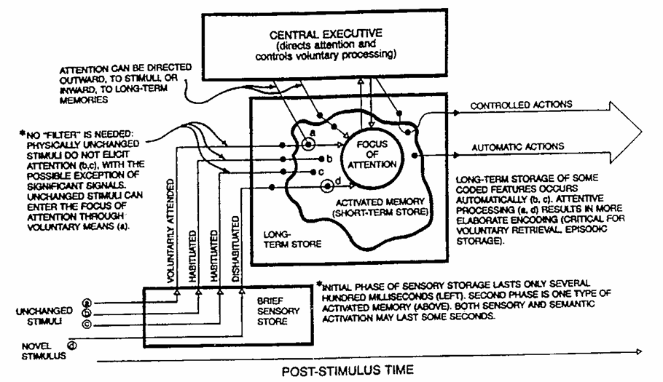
Figure 2

Going forward, there is a key question we need to consider. How does sleep effect memory consolidation? The author stated, “Evidence suggests that sleep plays a crucial role in memory consolidation after learning” (Gazzaniga, 2019, p. 417). I believe that some of the processing mechanics involved in sleep could prove useful in the operation of DL models.

References
Belcic, I, & Stryker, C. (2026). What is catastrophic forgetting? IBM.com. https://www.ibm.com/think/topics/catastrophic-forgetting
Copilot. (2026).
Cowan, N. (1999). An Embedded-Processes Model of working memory. In A. Miyake & P. Shah (Eds.), Models of working memory: Mechanisms of active maintenance and executive control (pp. 62–101). Cambridge University Press. https://doi.org/10.1017/CBO9781139174909.006
Gazzaniga, M., Ivry, R., & Mangun, G. (2019). Cognitive Neuroscience The Biology of the Mind, 5TH Edition.
Van de Ven, G. M., Soures, N., & Kudithipudi, D. (2024). Continual learning and catastrophic forgetting. In J. Wixted (Ed.), Learning and memory: A comprehensive reference (3rd ed., Vol. 1, pp. 153–168). https://arxiv.org/pdf/2403.05175
What is continual learning? (2026). IBM.com. https://www.ibm.com/think/topics/continual-learning

